Cheltenham Animal Shelter Newsletter – April update
Pet of the Month: Chester
At 17 years young, Chester came into our care in December after his owner sadly became unwell. This charming older gentleman is now looking for a calm and loving retirement home.
Chester is confident and affectionate and he enjoys his food, gentle company, and a relaxed wander around our cat garden (The catio). He would thrive in an adult-only home where someone is around for much of the day, and he would prefer to be the only pet.
He has a manageable thyroid condition, requiring simple daily medication and occasional monitoring, but this doesn’t stop him enjoying life.
If you know someone who could offer Chester a cosy spot to call home, we’d love to hear from them. Pease email cats@gawa.org.uk.
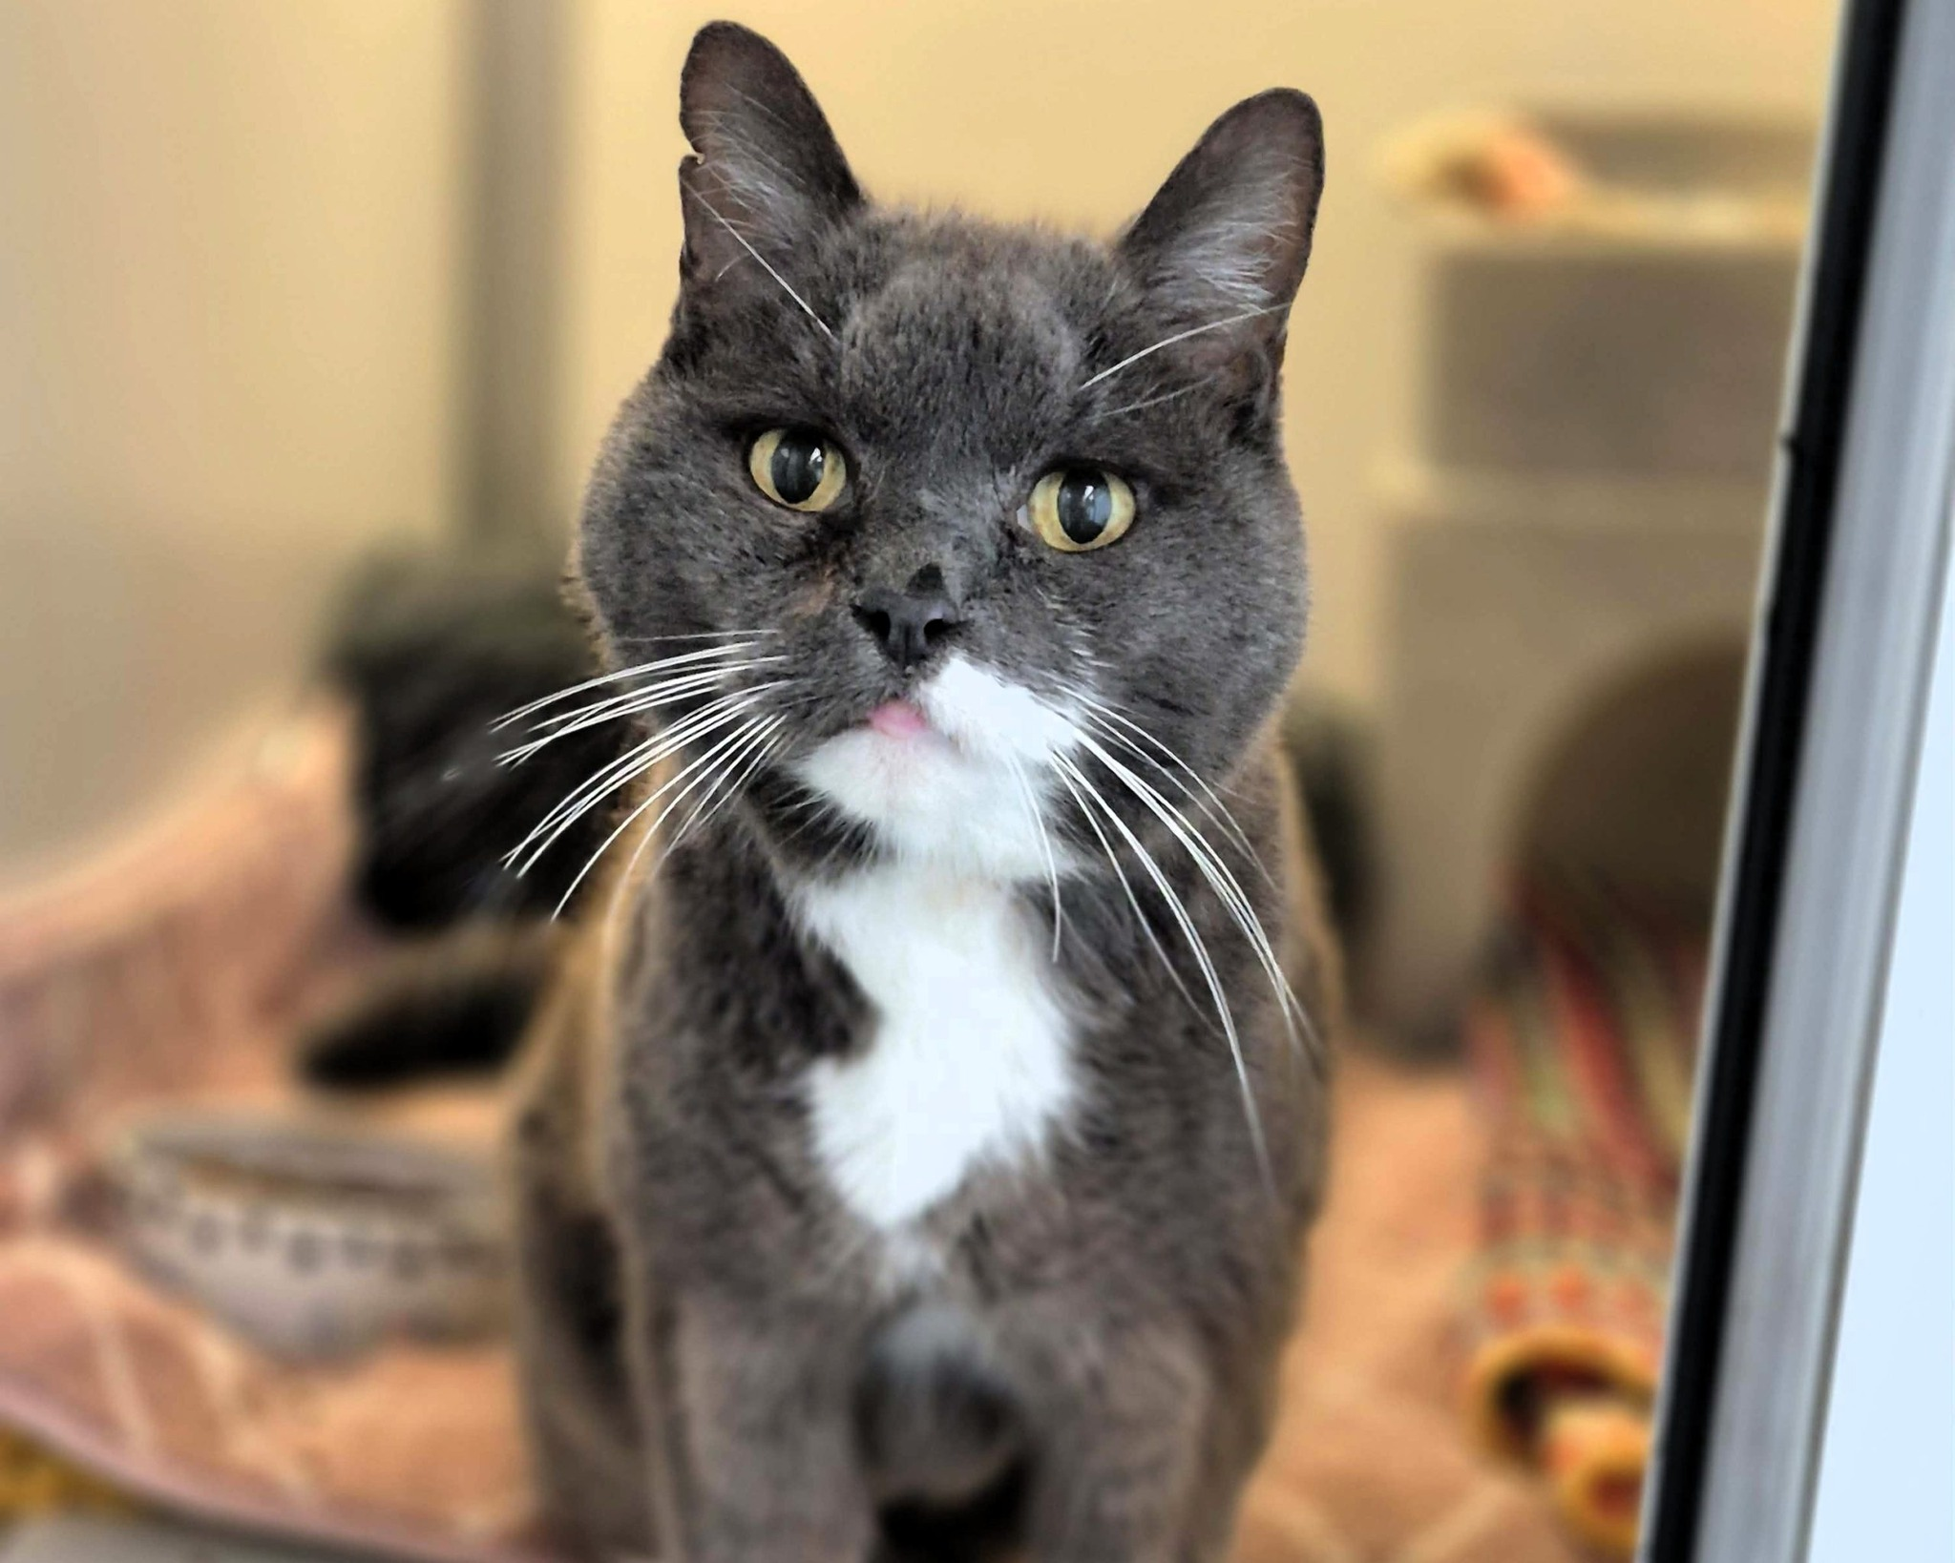
A Sudden Surge: Mothers and Kittens
Just a month ago, our cat section was unusually quiet, with around 15 cats in our care. Since then, numbers have more than doubled to 33 cats—17 of whom are kittens.
Several expectant mothers arrived as strays and gave birth shortly after reaching the safety of the Shelter. Soon after, two more cats were discovered abandoned in a layby, one heavily pregnant and the other already caring for three kittens. While most are now doing well, sadly one mother lost three of her kittens.
Thanks to your support, we’re able to provide these vulnerable families with warm, quiet spaces to nurse, nutritious food, and essential veterinary care. Preparing each kitten for rehoming which includes vaccinations and neutering is a cost of around £100 per kitten.
Your generosity ensures they have the best possible start before finding their forever homes.
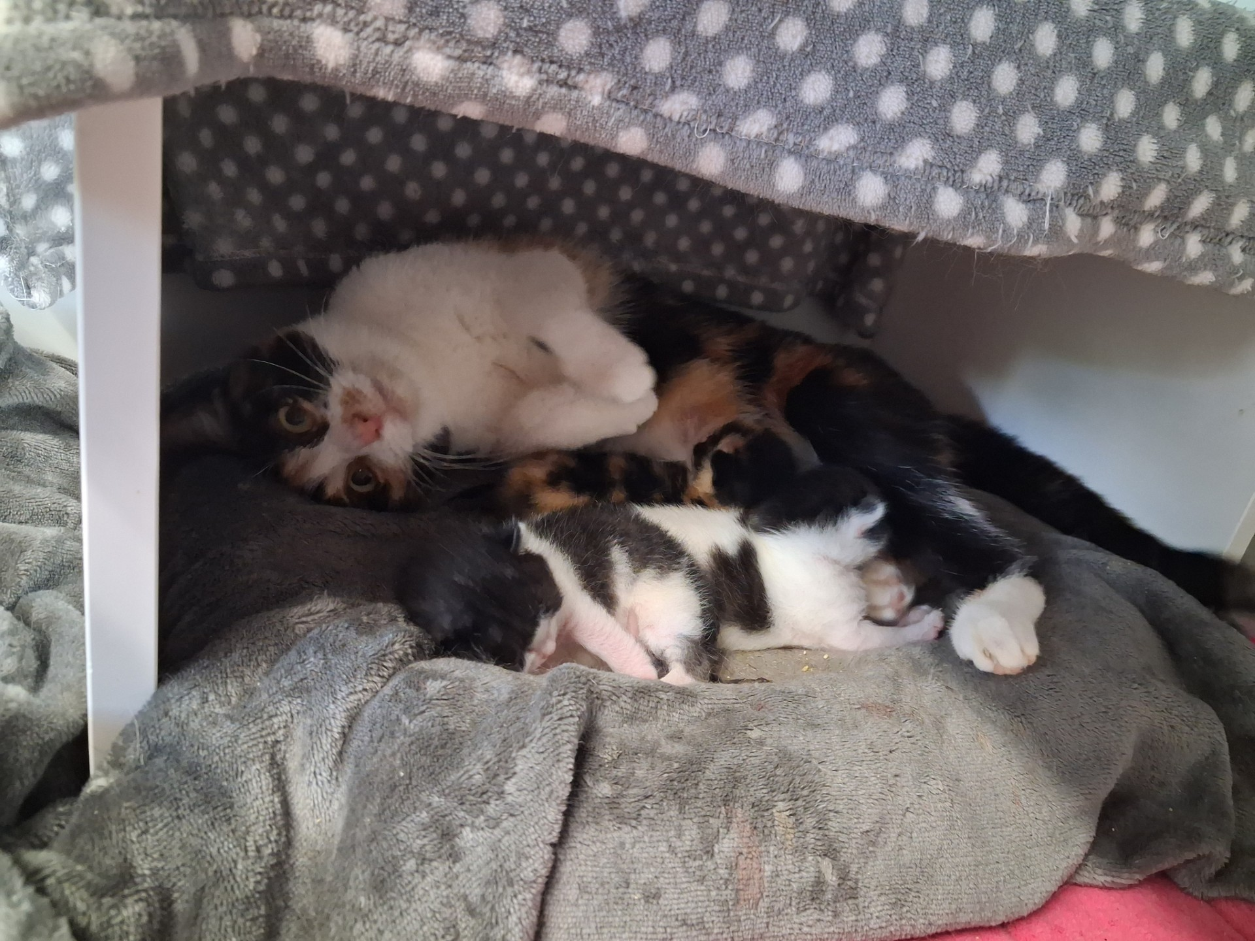
Centenary Raffle
This year marks an incredible milestone: 100 years of caring for animals in need.
To start the celebrations, we’ve launched our Centenary Raffle, giving you the chance to support our work while being in with a chance of winning fantastic prizes which include a top prize of £500, additional cash prizes, and a range of vouchers for days out and activities.

Every ticket purchased helps us continue providing life-changing care to animals who come through our doors.
To enter visit www.gawa.org.uk/raffle
Thank you for being such an important part of our work.

